**The earliest roads in Ogden: Pt 1 the inside track(s)**

**Introduction**

The fact is so obvious, it is easily overlooked. The *raison d’être* for nearly all rural municipal governments across Canada, is road maintenance. Ogden came into existence (see article by MA Courval) in 1932 because of a dispute over the (lack of) attention paid to road and bridge infrastructure in our immediate region, and to this day the Municipality’s principal focus, budgetary expense, and almost sole jurisdictional responsibility, continues to be its roads!

So how did Ogden’s road network come into being? Which are Ogden’s oldest known roads? Why are they, where they are? How have they been improved over the years (or have they)?

**Sources of Information**

The most accessible documents concerning our first roads are old maps. We are fortunate that nearly all of the key 19th century maps of the region have been preserved, and most can be viewed and downloaded online (see references). We can use these maps to produce a “stratigraphy” or historical sequence of when and where the roads were built.

The earliest maps that depict road networks in the Eastern Townships are those produced by Joseph Bouchette, Surveyor-General of Lower Canada from 1804 to 1840. Bouchette produced relatively detailed maps of Lower Canada on three occasions with the following scales: 1805 1 inch = 6 miles (1:380,160); 1815 1 inch = 2.75 miles (1:174,240); 1831 1 inch = 2.75 miles (1:174,240). All three are regional compilations, but it would appear that only with the last map (1831) did Bouchette personally inspect much of the territory, and this was done in the period 1826 to 1829.

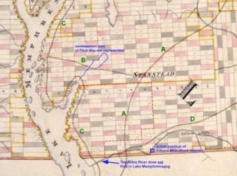The first two maps (1805 & 1815) were compiled in Quebec City based on information initially provided by deputy-surveyors, supplemented by township leaders and others from the frontier who were passing through the capital on business. This information, of highly varying quality, could not be independently verified by Bouchette himself. In any event, by the time they were issued or published, they would have been quite out-of-date. The frontier was rapidly evolving during these early times. The produced maps were as much propaganda and political tools as they were geographic representations (see Boudreau,1994), and some of the roads shown may have only been “proposed”, not actually constructed.

***Portion of map completed by July of 1805 by Joseph Bouchette illustrating 4 roads that pass through, or near, what is now Ogden (red outline). Lots shown are nominally 200 acres (except along the waterfront). Red lots were reserved for the Crown, grey ones for the Protestant Clergy.***

Ideally the oldest constructed map would show the earliest roads in existence. Unfortunately the 1805 map is grossly inaccurate with regards to other geographic and cultural features (see blue annotation), and cannot be trusted with regards to the roads shown. Nonetheless the roads are notionally correct, even if their precise placement is poor. For instance we know that early on a road was constructed to gain access to the more settled parts of Lower Canada, and in particular the towns of Trois Rivières and Québec (Road A). This road almost certainly passed the border at Kilborn Mills. There are records that indicate a road was built to connect Barnston with Stanstead in 1804 (D). According to Stewart, writing in 1815, a lakeshore road (C) was built in 1808-09, but perhaps some pre-existing trail linking the early farmsteads was already in place by 1805. Such a path, that would have carried on into Vermont, is entirely reasonable given known settlement patterns, although the loop to Magoon’s Point may not have existed at this time. Road B is very problematic, but the junction between B and C could represent Georgeville (established in 1797), although its placement on the map is too far south (should be at Lot 26). If this Georgeville assumption is correct, then road B could represent one of several possible routes to Stanstead (i.e. straight to Narrows, or north by the head of Fitch Bay).

**Who built the earliest roads**

Unlike other townships, where settlement roads (e.g. Craig, Gosford) preceded initial settlement, in the southern half of Stanstead Township (Ogden) it was the crude cart and sled paths through the wilderness, carved out by the settlers themselves, which eventually coalesced into the road network we have today. The majority of the first settlers coming into the Township of Stanstead were squatters[1]. They either arrived from the west (i.e. the area around Missisquoi Bay), or travelled from the south by way of the primitive road constructed in 1791-93 by Timothy Hinman, from Greensboro Town to Derby in Vermont, and later extended to Johnson Taplin’s (circa 1796) clearing in what was to become the village of Stanstead Plain.

***Timothy Hinman, pioneer settler of Derby, Vermont, who organized the construction of ___km of new roads in northern Vermont, and some histories indicate also in Lower Canada.***

Once would-be settlers arrived in the Township, how would they know which 200 acre Lot was which? The internal division of Stanstead Township into lots was completed in 1794 by Joseph Kilborn, deputy-surveyor, and his team. The result of this survey was a series of north-south and east-west *blazed lines*, cleared only where necessary to allow for efficient sighting along lines using an inferometer (magnetic compass). At the corners of the Lots, a blazed tree, or in the absence of a suitable tree, a post, would presumably[2] indicate the quadrant, the Lot number and the Range number (e.g. **NE, L. 4 R.5**).

Typically potential settlers would conduct a reconnaissance in late summer of the Township to ascertain on which Lot a pitch[3] could be most advantageously made. They would do this unencumbered by their immediate family (wives and young children), but often in the company of neighbours who also intended to settle, and/or brothers, cousins, older sons, or friends, in short, one or more helpers handy with an axe. At this time, or on a subsequent visit, a crude shanty or shelter would be constructed. Wilderness trails would be blazed, some of these would follow the 1794 survey lines, but others would be newly made if they offered a significant shortening of the distance from the desired Lot and the nearest established route into the Township. Whole families would then make the migratory trek, most often in late winter or early spring, when there was sufficient snow (or thick ice) for travel with an ox-pulled sled. The sled would have to be large enough to bring critical family possessions, seeds, and sufficient provisions to last at least until fall harvest. If the existing trail was insufficient (or couldn’t be located), then an enlarged or new path for the sled would have to be cut. Subsequent settlers would obviously use as much of the previously built trails as possible, and as a result preferred pathways or routes became established, whereas others of less utility, were quickly abandoned.

**Factors that determined the location of the first trails**

The shortest route was not always the best route, and even the initial crude forest cart paths tended to avoid low-lying poorly drained areas where possible. The higher terrain also tended to be less densely forested (see Mackenzie,1996), and paths would have been less onerous to clear. A simplified topographic map of Ogden with the oldest preserved roads, illustrates this preference for the “high” ground.

Apart from achieving somewhat drier and more passable mud roads, the co-location of these early tracks and high ground also derived from the fact that many of the first homesteads in Ogden were preferentially sited on the uplands. For example a good number of the earliest settlers originally came from Unity and Marlow in the hill country of New Hampshire, and the gentle rolling countryside of what is now Ogden, would have been both familiar and desirable[4]. These settlers’ prior experience dictated their selection of Lots, resulting in the establishment respectively of Griffin, and the Marlow Settlement (later Marlington).

Of course, the earliest roads would have connected these pioneer farmsteads, as communication with one’s neighbours in the harsh and sparsely populated wilderness was vital for safety, assistance, and the simple pleasure of socializing.

The final priority for the settler cart paths was communication to millsites, the earliest mills being established on the Tomifobia River in 1800 (near present day hamlet of the same name), and 1803 (Kilborn Mills – present day Rock Island).

As the following maps illustrate it was the access trails built by the early settlers that formed most of Ogdenˊs current road network. Most of our roads date from at least the late 1820ˊs and likely much earlier, as is evident by examining the maps produced by Bouchette in 1831, and Colonel Gore in 1838[5].

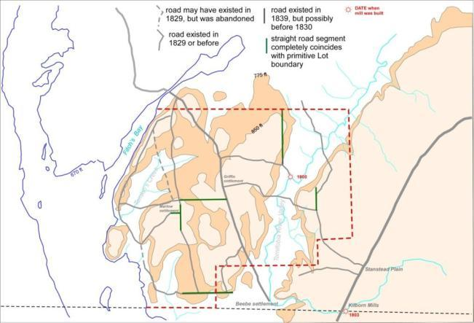

***Sketch map of Ogden showing simplified topography. Those roads known to have existed in 1829 are shown in grey. Over 90% of the earliest roads were located on elevated ground in Ogden (defined as being at least 100 ft above the level of the Lake). Straight line road segments shown in green, are those that coincide with “primitive” or original Lot boundaries. Where the roads coincide with original Lot boundaries, these roads invariably date as some of the oldest in Ogden, suggesting the initial use by some settlers of the blazed lines from the internal Township survey (1794), as wilderness pathways. Later, some of these became formalized as public roads, or parts thereof. However the majority of roads clearly cut across Lot boundaries in a more random fashion, being the shortest and driest routes between farmsteads. Note that no early roads ran up the Tomifobia River Valley, although three crossed it.***

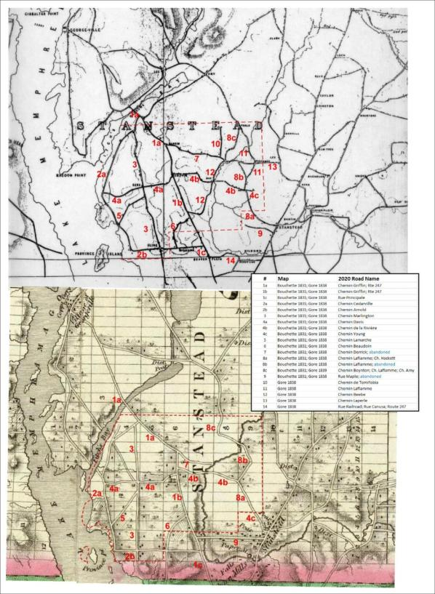

***Comparison of portions of the maps produced by Colonel Gore (1838) at top and Joseph Bouchette (1831) at bottom, and that cover Ogden. Red numbers can be keyed to modern road names in the Table provided. A digital copy of a facsimilie of the rare Gore (1838) map was kindly provided by David Lepitre.***

**Making Better Roads**

**Macadamization, metalling, and “improved” roads.**

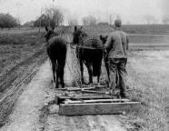Simple dirt or earth roads, under dry conditions, could support limited, light wheeled traffic. Indeed as late as 1928, over half of all the road mileage in Canada were earth roads. However more frequent traffic and heavier wagons and stages, quickly rutted these roads and made them practically impassable. The inadequate width of the iron-rimmed wheels was often cited as the culprit for rapidly deteriorating dirt roads, as the thinner (but arguably faster) wheels quickly dug into the roads. Crude “drags” would be used to smooth out the ruts, but such maintenance was never-ending. What was really required was a more durable road surface.

***Primitive wooden drag being used to smooth out a dirt road. Note rutted nature of road ahead of the rig.***

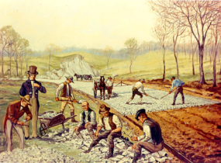Several attempts had been made over the years to achieve this, but the most practical approach was put forward in 1816 by the Scottish civil engineer, John Loudon McAdam[6]. He advocated a very slightly cambered roadbed, raised above its surroundings (and definitely above local water table), consisting of two relatively thin layers of crushed stone, laid on a compacted subsoil. The lower layer was about 8” thick and was composed of uniform angular pieces of crushed rock, each about 2-3” in diameter. This layer gave the road its integrity/strength and distributed the load from whatever traffic the road would endure. The upper layer was about 2” thick, and consisted of uniform crushed rock pieces around ¾-1” in diameter, hand-rammed into place. This upper layer was the *wearing surface* of the road and provided a firm footing for hooves and wheeled vehicles. If the upper surface was sufficiently compacted, it would also serve to shed rainwater to the ditches, ideally dug on either side. McAdam did not advocate that any binding agent be used, but in practice, it was common for the rock dust derived from the crushing process to be distributed over the upper surface.

There were many subsequent variations developed (i.e. number of layers, thickness, size of stone, gravel instead of crushed rock, inclusion of binders including tar), but this process of improving the durability of the road, of stabilizing its surface by using crushed rock or gravel, was refered to as *macadamization*. The crushed stone that “armoured” the road, was refered to as road “*metal*”.

***1823. America’s 1st macadam road (the Boonsborough Turnpike***

***Road) being built in Maryland. Painting by Carl Rakeman, 1926.***

Macadam roads were being built in Upper Canada as early as 1837, and in Lower Canada by the 1840’s.

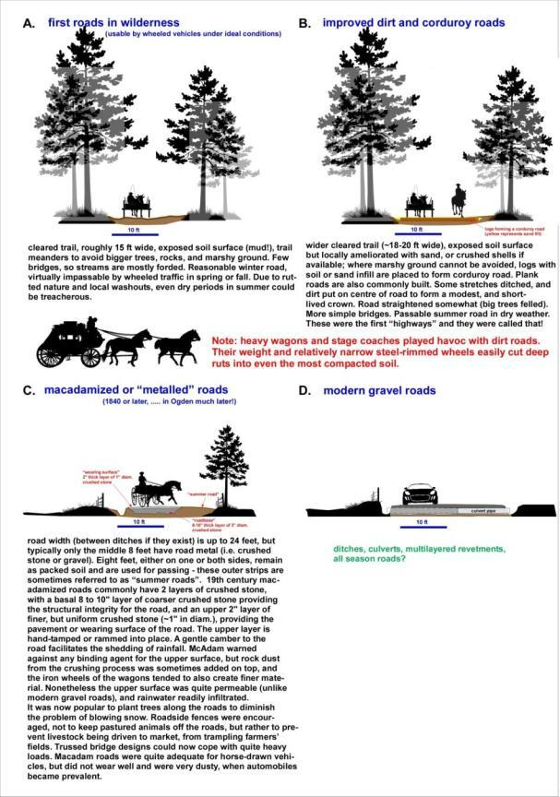

**Better roads gradually come to Ogden[7]**

In 1913 all of Ogden’s roads were still simple, relatively narrow, dirt roads. Most had been improved somewhat by ditching, smoothing through the use of a pull-grader, and the building of wooden bridges where absolutely necessary. None had been improved by applying surface *metal*, nor had any been widened beyond 18 feet[8]. Indeed the only really improved roads in the near vicinity were Dufferin Street in Stanstead, and its extension towards Sherbrooke (today’s route 143), which were considered “*metalled*” roads. There were however **43** wooden bridges within the limits of what would become Ogden. Most of these bridges were very small but very important, acting as culverts where the dirt roads passed over the innumerable small streams. Maintaining them must have been a challenge and a considerable expense. No doubt washouts were common, and sections of the road network were probably impassable at certain times of the year.

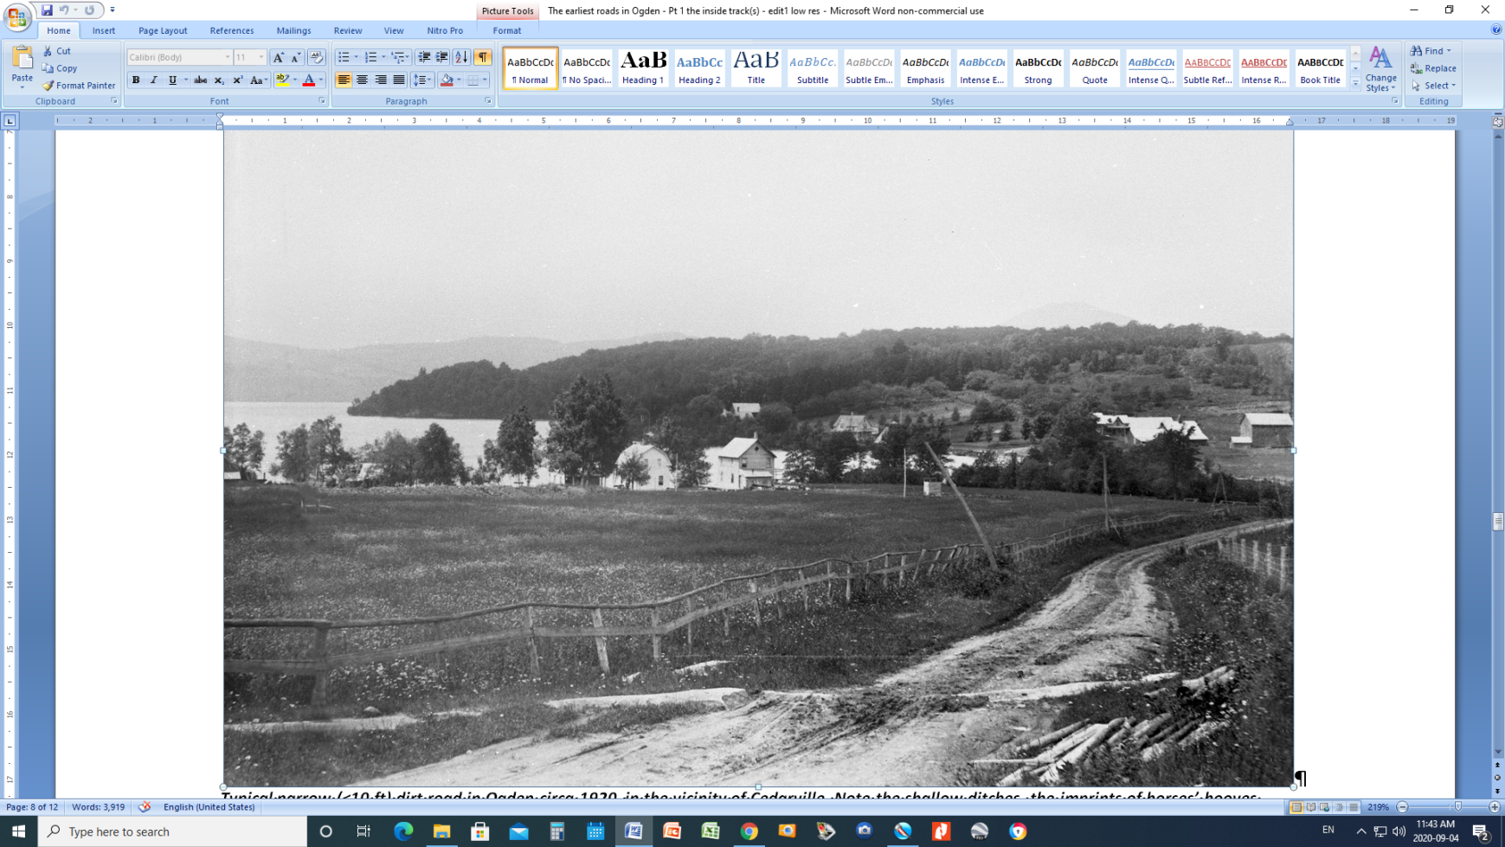

***Typical narrow (<10 ft) dirt road in Ogden circa 1920, in the vicinity of Cedarville. Note the shallow ditches, the imprints of horses’ hooves dominating the centre, with wagon wheel ruts on either side, and the obstacle in the form of a ledge of granite running across the road. The “dirt” for the road was simply what had been obtained when digging the ditches on either side.* Image courtesy of JJ Parker Coll. SHS**

By 1931, just prior to Ogden becoming a separate municipality, a route defined by today’s Chemin *Hackett* to *Youn*g to *de la Rivière* to *Stanstead* to Chemin *de Tomifobia*, had been improved, and was considered a *metalled 2nd class* road. All other roads remained as before, dirt.

The 1936 issued topographic map shows Dufferin–Route 143 as paved. Upgraded (metalled) roads under 18 feet wide included Chemin *Maple* to *Stanstead* to Chemin *de Tomifobia*; as well as Rue *Principale* in Beebe to its junction with Chemin *Beebe*, plus Rue *Junction* to Ch *North Derby* up to Gline Corners to the Graniteville corner.

By 1944 the paving had extended from Rue *Railroad*, *Canusa*, Rue *Principale* to the junction with Rue *Junction*. Paving continued on the latter to its junction with *North Derby*. Additional improved roads included Chemin *Hackett* to its junction with Ch *McShane*; Rue *Maple* to Ch *Stanstead* to Ch *Tomifobia*; Chemin *Griffin* (Route 247) from Beebe to just north of Chemin *Bell*; and finally Rue *Junction* to *Marlington* to Graniteville corner, then along Chemin *Cedarville* to just southeast of Harveys Bay.

In 1957 the executors of Ronald Weir’s estate had a dilemma. As per Ron Weir’s wishes, they planned to donate a significant amount of lakeshore property to establish a public park for the benefit of local residents of Ogden, Beebe, Rock Island, and Stanstead, particularly for those citizens who had no immediate access to Lake Memphremagog. Unfortunately the public highway as it was then routed, passed over the Weir estate lands, right by the beach. At that time Chemin *Cedarville* was a provincial road, so the executors negotiated with the province for a land swap. A portion of the estate was ceded to the government in order to build a by-pass road (paid for by the province), in return the estate was able to reclaim and dismantle the lakeshore portion of the road. Weir Memorial Park was officially opened on July 1st, 1959.

By 1968, paving was extended from Beebe to Graniteville. The asphalt went along Rue *Junction* and Chemin *Marlington* and was extended both north and west somewhat to include all of the hamlet of Graniteville. Presumably this pavement was deemed necessary to lessen the wear and tear placed on the road by the heavy trucks now hauling granite from the quarry. Chemin *Beebe*, *Stanstead*, the rest of *Cedarville* to the junction with *Arnold*, all of Chemin *Marlington* and *Griffin* (247), are considered “loose or stabilized surface all weather roads greater than 2 lanes wide”. All other roads in Ogden are “loose, stabilized surface all weather less than 2 lanes”. Minor portions of roads (i.e. *Arnold*, *Laperle*, *Laflamme*, former extension of *Embury*) are labelled “loose surface dry weather”.

By 1978 paving has been extended along Chemin *Cedarville* to about 150m north of its junction with Chemin *Lamarche*. Precisely when and why this was done remains somewhat of a mystery. Was this portion of the road, and only this portion, deemed a provincial road? At the same time provincial Route 247 (Chemin *Griffin*) was paved from Graniteville to its junction with Chemin *Bell*. Chemin *North Derby* was also paved in this time period. All other roads at this time are categorized as loose surface or stabilized, and classified as either greater than, or less than, 2 lanes in width.

**When did Ogden start to name its roads????**

**Summary and Road Stratigraphy**

Almost all of Ogden’s current public road network was constructed prior to 1881, and evidence from old maps would suggest the vast majority of our roads were in existence by 1829. Indeed many of the routes are significantly older still. On the interpretive map below, one can see that two roads, Chemin *Cedarville-Arnold* and Chemin *Griffin* (247) date from the period of earliest settlement[9]. However when we plot some of the locations and dates of Ogden’s first clearings (blue-coloured dates), one can see that they align with Chemin *Marlington* as well as Chemin *Hackett-Laflamme*- these too must be of equally early origin, all of them serving to link the isolated farmsteads in the region.

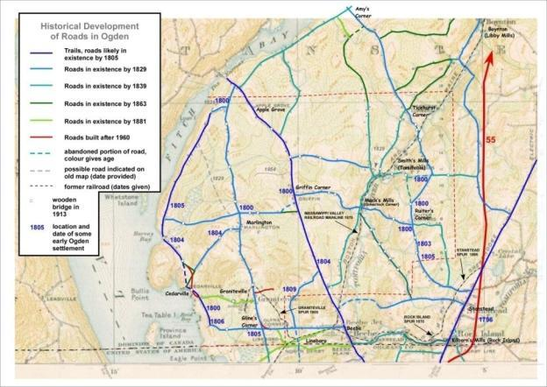

***An interpretation of the approximate ages of the roads in Ogden. The base map is a portion of the topographic map published by the Department of the Militia & Defence in 1917, with road and other culture surveyed in 1913. At that time all of Ogden’s roads were narrow (<12 feet) and dirt (not gravel), unchanged from the early 1800’s. The date of 1829 is somewhat arbitrary and is given to any information seen on Bouchette’s map published in 1831. Data on this map cannot be younger than September of 1829, as this is when Joseph Bouchette left for Britain.***

It is a remarkable testament to the inertia that follows the building of roads, that so few routes have been either abandoned or changed. The coming of the railway in 1870 was the impetus for building the *North Derby* road, and of course the development of the granite quarries in the vicinity of Graniteville also in the 1870’s, spawned the construction of the Graniteville-Cedarville link. The present geometry of the road near Cedarville was constructed in 1958 to accommodate Weir Park. Paving of Chemin *Marlington* to Graniteville was necessitated when the railway spur to the quarries was abandoned and heavy trucks came into use to haul the granite to Beebe (and beyond). Route 247 was paved because it was a provincial highway (date), and the small portion of asphalt on Chemin Cedarville was laid, presumably to facilitate tourist traffic to Weir Park.

There has been, of course, a boom in road construction in Ogden, that commenced in 1904, but really took off after 1950 and has continued to the present. This was the building of private roads (descentes) to access summer cottages along the lakeshore. This cottage boom is the subject of a separate article.

**References**

Andreae, Christopher (Historical Research Ltd.) 2001 *Road Construction in Canada: 1860 – 1910*. Unpublished report prepared for the National Museum of Science and Technology, 70pp.

Bingham, Norman W. 1892 Sketch of the Life of Hon. Timothy Hinman: An address delivered before the Orleans County Historical Society, Derby, Vermont Sept 1st 1891- Also geneology of his descendents. Press of the Somerville Citizen, Somerville, Mass., 35pp.

Bouchette, Joseph 1805 Connected Plan of the several townships situated to the southward of the River St. Lawrence on which are laid down the settlements & roads from the best information; also shewing the lands granted and those remaining ungranted in each township with the proportionable reservations therein allotted & appropriated for the maintenance & support of the protestant clergy within this province and for the future disposition of His Majesty. Compiled from the different actual surveys which have been made since the year 1792. By Order of His Excellency Sir Robert Shore Milnes, Bart., Lieutenant Governor of the Province of Lower Canada. By Joseph Bouchette, S. Gen1. Quebec July 1805.

Bouchette, Joseph 1815

Bouchette, Joseph 1831

Boudreau, Claude 1994 La cartographie au Québec 1760 – 1840. Les Presses de l’Université Laval, 135pp.

Caron, Ivanhoe 1933 Historique de la voirie dans la province du Quebec; Bull. des recherches historiques, v.39, April, p.198-215.

Cleveland, Rev. Edward 1858 A Sketch of the Early Settlement and History of Shipton, Canada East. S.C. Smith, printer, 78 pp.

Hubbard, B.F. (compiler) 1874 *Forest and Clearings: The History of Stanstead County Province of Quebec with Sketches of More than Five Hundred Families*; revised abridged and published by John Lawrence, Lovell Printing and Publishing Co., Montreal, 367pp.

Kesterman, J.-P., Southam, P., Saint-Pierre, D. 1998 *Histoire des Cantons de l’Est*; Les Presses de l’Universite Laval, Sainte-Foy, 829pp.

Little, J.I. 1981 Colonization and Municipal Reform in Canada East; Histoire Sociale – Social History, v. XIV, no 27, p.93-121

Mackenzie, Katherine 1996 *Indian Ways to Stagecoach Days: New Hampshire Vermont Quebec;* Pigwidgeon Press, Ayers Cliff, 128pp.

Martel, Fr. Jules 1960 *Histoire du système routier des Cantons de Lˊest avant 1855*; Dissertation pour MA, Univ. Ottawa, 271pp.

Sangree , Gail A. 2002 The Checkered Career of Timothy Hinman. Vermont History vol.70 (Summer/Fall) p. 111–129.

1. Most of those who held legal title to the lots (the associates), declined to move to the Stanstead wilderness, and for many there was never any pretension to do so. In essence they were paper claimants, used by Isaac Ogden to legitimize his petition. In fairness, some of the associates were genuinely enthusiastic to settle the township, including Thomas Filer, Johnson Taplin, Charles Kilborn, Andrew Young, and Israel Wood.
2. Currently being investigated.
3. This was a common term referring to the first clearing in the woods a settler would make.
4. There was a common belief that the lower lying areas were less healthy (reference). Obviously farmers arriving from the very fertile Connecticut River Valley bottomlands would disagree.
5. Bouchette’s map is less precise, with the roads exhibiting an unrealistic rigid geometry, and homesteads only symbolically represented. Bouchette’s data was collected in the period 1827-29. In contrast the military surveyors working for Gore, were pursuing a more accurate representation. Their data were less than 1 year old by the time the map was drafted. Both maps suffer from errors of omission (e.g. missing roads), but collectively they provide a very informative view of the Township of Stanstead.
6. The Americans misspelled his name, as a result we are left with *macadam* and *macadamization*.
7. This section is based on the 1”=1 mile and subsequent 1:50000 scale topographic maps produced for 031/H1 Lake Memphremagog map sheets. Culture, including road information, was updated about every decade. More precise information should be available in Council minutes.
8. This width of the road surface would exclude any ditching.
9. Based on data from Bouchette’s 1805 map